Group & Private Sessions
All sessions are at Larry Grossman Arena, unless noted. All sessions are 60 mins, and may include flood.
 | SUNDAY | MONDAY | TUESDAY | WEDNESDAY | THURSDAY | FRIDAY | SATURDAY
PASS  (Parent Assisted Skater Session)  Group | PHIL WHITE  10:00-10:40am  10:40-11:20am  11:20-12:00pm
PreCanSkate  CanSkate 1-6  Group  Includes STAR 1* | Small Ice  4:30-5:30pm  PHIL WHITE  10:00-10:40am  10:40am-11:20am  11:20-12:00pm | Small Ice  5:00-6:00pm | Large Ice  4:00-5:00pm |  | Small Ice  5:00-6:00pm* |  | Small Ice  8:15-9:15am  9:15-10:15am  1:15-2:15pm*  2:15-3:15pm
POWER HOUR:  PrePower & CanPower Group  (Full Hockey Gear & Sticks) |  |  |  |  |  | Small Ice  5:00-6:00pm | Small Ice  2:15-3:15pm
DOUBLE DIGIT | Small Ice  7:30-9:00pm*** |  | Small Ice  8:15-915pm |  | Large Ice  8:00-9:00pm
BRONZE PRIVATE  LTS | Small Ice  5:30-6:30pm  6:30-7:30pm  PHIL WHITE  8:00-9:00am  9:00-10:00am  12:00-1:00pm | Small Ice  4:00-5:00pm  6:00-7:00pm | Small Ice  5:15-6:15pm  6:15-7:15pm | Large Ice  4:00-5:00pm  Small Ice  5:00-6:00pm | Small Ice  4:00-5:00pm  Large Ice  5:00-6:00pm | Small Ice  4:00-5:00pm  6:00-7:00pm  7:00-8:00pm | Small Ice  10:15-11:15am  11:15-12:15pm  12:15-1:15pm
SILVER PRIVATE  Star 1 – 2  **Star1-2 only | Small Ice  6:30-7:30pm  7:30-8:30pm  PHIL WHITE  8:00-9:00am  9:00-10:00am  12:00-1:00pm | Small Ice  4:00-5:00pm  6:00-7:00pm | Small Ice  6:15-715pm  7:15-8:15pm** |  | Large Ice  4:00-5:00pm**  5:00-6:00pm | Small Ice  4:00-5:00pm  6:00-7:00pm  7:00-8:00pm | Small Ice  10:15-11:15am  11:15-12:15pm  12:15-1:15pm
GOLD PRIVATE  Star 3+ |  |  | Large Ice  5:00-6:00pm  6:00-7:00pm | Large Ice  5:00-6:00pm  6:00-7:00pm | Large Ice  6:00-7:00pm  7:00-8:00pm | Large Ice  5:00-6:00pm  6:00-7:00pm
FHFSC Off Ice Classes |  |  |  |  | Workout Room  6:15-7pm |  | Workout Room  10:30-11:15am
ADULT Skating | Small Ice  7:30-9:00pm*** |  | Small Ice  8:15-9:15pm |  | Large Ice  8:00-9:00pm
Hockey ADULTS |  |  |  |  |  | Small Ice  8:00-9:00pm
SUNDAY NIGHT LIGHTS*** | Small Ice  8:30-9:00pm
PRIVATE LESSONS:
FHFSC is pleased to offer over 25 hours/week of private ice time.
Finding a coach:
Go to www.fhfsc.ca, programs, private instruction

Private lessons involve 2 costs:
- Ice time fees plus annual Skate Canada Fee and Admin fee paid to FHFSC before the skater steps on the ice.
- Private lesson feed paid directly to the coach.

HELMET POLICY:
PASS, PreCan, CanSkate, PrePower, Power, Double Digit & Adult participants up to & including stage 5 must wear a CSA approved hockey helmet while on the ice. Helmets with face grills are mandatory for Power Hours.

REFUND POLICY:
FHFSC does not issue refunds, credits, make-up sessions, or ticket ice for any reason other than medical withdrawal from a program and must accompany a doctor’s note.

FHFSC reserves the right to cancel sessions if minimum registration requirements are not met or other related reasons. You will be notified in advance.

Note: some Tuesday/Wednesday 4pm Large Ice sessions will change to Small Ice due to arena ice schedule.

For more information on our policies & procedures, please visit our website:
WWW.FHFSC.CA
LEARN TO SKATE PROGRAMS

PASS Program
- Age 2+
- Parent Assisted Skater Session
- One parent per skater
- Helmets are mandatory for both skater and parent
- Coach/Skater+Parent Ratio 1:6
PreCanSkate
- New skaters age 4+
- No skating experience
- Coach/Skater Ratio 1:4
CanSkate/Star 1
- Ages 4-10
- Able to skate unassisted
- Working on CanSkate 1-6
- Working on Star 1 level
- Coach/Skater Ratio: 1:10
Double Digit
- Ages 11+
- Able to skate unassisted
- Coach/Skater Ratio: 1:8
Adult LTS
- Ages 18+
- Able to skate unassisted
- Coach/Skater Ratio: 1:8
Hockey Adults
- Ages 18+
- Able to skate unassisted
- Coach/Skater Ratio: 1:8
Sunday Night Lights -ADULTS
- Fun Group Session
- Cool Lighting
- Great Music

For more information on our Learn To Skate programs, please visit our website:
WWW.FHFSC.CA
HOCKEY SKILL PROGRAMS

PrePower
- Canskater 1-4 Level skaters
- Hockey gear optional
- Helmets with grill are mandatory
- Coach/Skater Ratio 1:8
Power
- Hockey specific skating skills
- Must have passed CanSkate 4
- Full hockey gear required
- Coach/Skater Ratio 1:8
Hockey Parents
- Fun night of hockey skating skills
- Hockey gear optional
- Helmets with grill are mandatory
- Coach/Skater Ratio 1:8

PRIVATE LESSONS & OFF-ICE

BRONZE
- Skaters learning to skate(LTS)
SILVER
- Star 1- 2 level skaters
GOLD
- Star 3+ level skaters
Qualifications:
-must be able to do a loop jump, camel spin/or sit spin and fast stroking skills with crosscuts(no toe picks)
-must be approved by skating director
WORKOUT ROOM -Off-Ice classes
- Add a FHFSC off ice class
- Ask your coach about off ice classes

For more information on our Hockey Skills and Figure Skating programs, please visit our website:
WWW.FHFSC.CA
2023-2024 Season
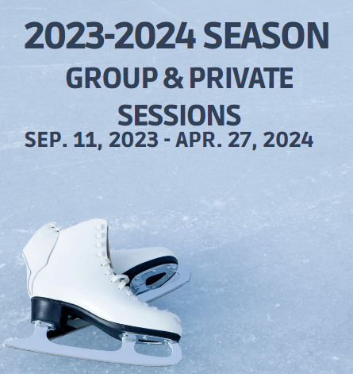
Larry Grossman Arena
340 Chaplin Cres
Toronto, ON
FULL SEASON:
Sept. 11, 2023 – Apr. 27, 2024
(31 Weeks)
Season 1: Sept. 11 - Oct. 28
(7 Weeks)
Season 2: Oct. 29 - Dec. 23
(8 Weeks)
Season 3: Jan. 7 – Mar. 2
(8 Weeks)
Season 4: Mar. 3 – Apr. 27
(8 Weeks)
Phil White Arena
443 Arlington Ave
Toronto, ON
FULL SEASON:
Oct. 15, 2023 – Mar 17, 2024
(21 Weeks)
Season A: Oct. 15 - Dec. 24
(Excluding Nov 19) (11 weeks)
Season B: Jan. 7 – Mar. 17
(11 Weeks)
Schedule and Pricing is subject to change
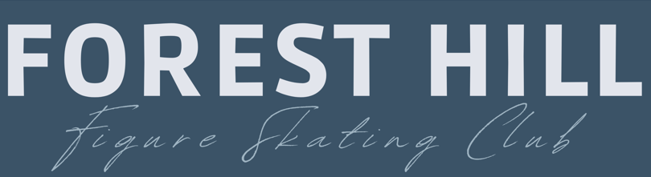

2023-2024 S EASON
GR OUP & OPEN
SESSION

WWW.FHFSC.CA
E-MAIL: office@fhfsc.ca

